

Progress Report

I.C.E



October 28, 2019

Thomas J. Short

CIS 260-01

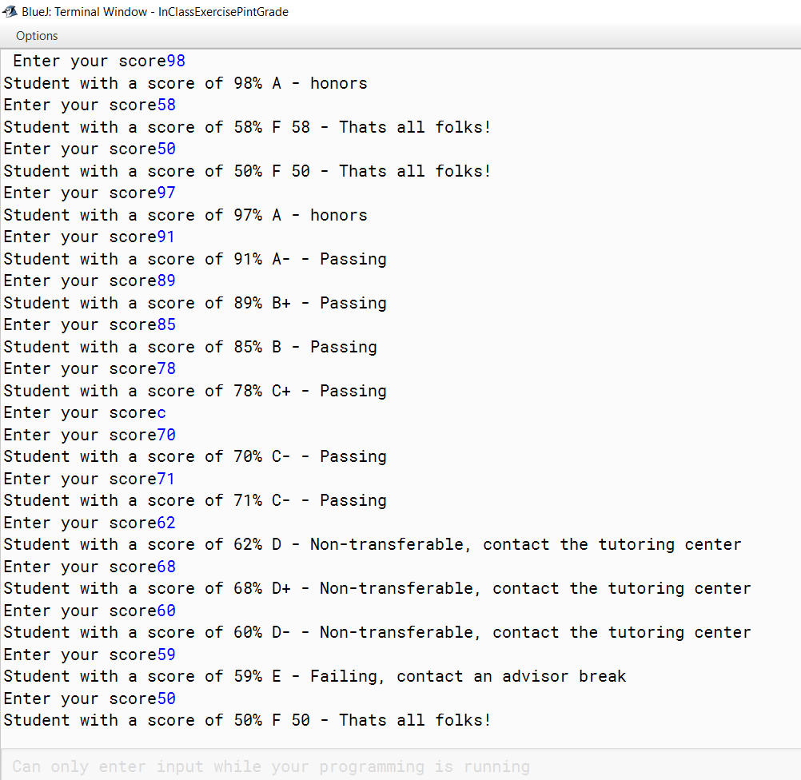PRINT GRADE: Result